OBB (Austrian Railways, red) Railjet trains.
There are two types of Railjet, both 7-car. Below is the original type, with 16 business class seats, the later type has only 6 business class seats.
All cars have toilets, all seats have 230v power sockets. Suitcase symbol = large luggage rack.
Some Prague-Vienna departures are operated by Austrian (red) railjets with different interiors.
Note that two 7-car railjet sets can run coupled together, in which case car numbers in the second set will be 31, 32, 33 etc.
Car 21 - 2nd (economy) class.
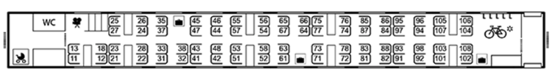
Car 22 - 2nd (economy ) class
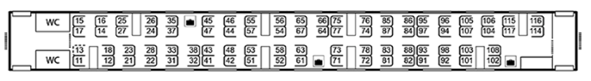
Car 23 - 2nd (economy) class
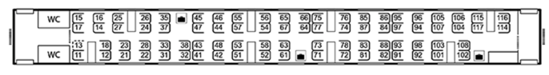
Car 24 - 2nd (economy) class
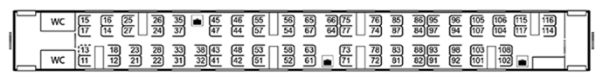
Car 25 – 1st class & restaurant car
Car 26 - 1st class
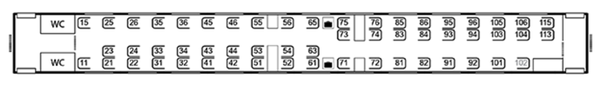
Car 27 - business class (= premium 1st) & regular 1st class.
